**Lab 3**

Aditya Kamble

1. Create a superclass Person with attributes name and age, and a method display(). Create a subclass Student that adds an attribute studentID. Write a program to create a Student object and display all its attributes.

-

**package** raju;

**class** student

{

**void** disp(**int** n){

System.***out***.println("Student id="+n);

}

}

**public** **class** personnn **extends** student

{

**public** **void** name(String name) {

{

System.***out***.println("student name="+name);

}

}

**public** **void** age(**int** age) {

{

System.***out***.println("student age="+age);

}

}

**public** **static** **void** main(String[] args) {

personnn obj1=**new** personnn();

obj1.name("raju");

obj1.age(24);

obj1.disp(100);

}

}

Output-

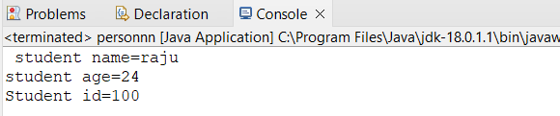

1. Create a superclass Calculator with a method add(int a, int b). Create a subclass AdvancedCalculator that overloads the add method to handle three integers.

-package raju;

class calcu{

int c;

public int third(int c) {

return this.c=c;

}

}

public class advance extends calcu{

int a;

int b;

int sum;

public void add(int a,int b) {

this.a=a;

this.b=b;

sum=a+b+c;

System.out.println("sum="+sum);

}

public static void main(String[] args) {

advance obj1=new advance();

obj1.third(10);

obj1.add(12,14);

}

}

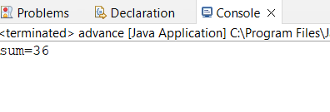

3.     Create a superclass Vehicle with a method move(). Create subclasses Car and Bike that inherit from Vehicle. Write a program to create objects of Car and Bike and call the move() method on each.

-

package raju;

class cars extends bike

{

void move()

{

System.out.println("car is moving");

}

void nomove()

{

System.out.println("car is not moving");

}

}

class bike

{

void run()

{

System.out.println("bike is moving");

}

void norun()

{

System.out.println("bike is not moving");

}

}

public class carbike extends cars{

public static void main(String[] args) {

carbike car=new carbike();

car.move();

carbike bike=new carbike();

bike.run();

car.nomove();

bike.norun();

}

}

Output-

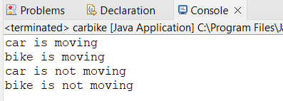

5.     Create an class Document with an method void open(). Implement subclasses WordDocument, PDFDocument, and SpreadsheetDocument that extend Document and provide implementations for open(). Write a main class to demonstrate opening different types of documents.(implement complile time- polymorphism).

-package raju;

class WordDocument extends document

{

void open()

{

System.out.println("open worddocument");

}

}

class pdfdocument extends document

{

void open()

{

System.out.println("open pdfdocument");

}

}

class SpreadsheetDocument extends document

{

void open()

{

System.out.println("open spreadsheetdocument");

}

}

public class document {

public static void main(String[] args) {

pdfdocument obj=new pdfdocument();

obj.open();

//wordDocument obj1=new wordDocument();

//obj1.open();

SpreadsheetDocument obj3=new SpreadsheetDocument();

obj3.open();

}

}

Output-

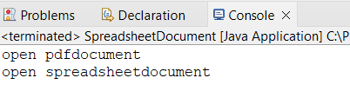

6.     Create a class Calculator with overloaded methods add() that take different numbers and types of parameters: int add(int a, int b)

double add(double a, double b)

-

**package** raju;

**public** **class** doublecalci {

**public** **double** a;

**public** **double** b;

**public** **double** c;;

**static** **double** *sum*;

**public** **double** add(**double** a,**double** b)

{

**return** *sum*=a+b;

}

**public** **double** add(**double** a,**double** b,**double** c)

{

**return** *sum*=a+b+c;

}

**public** **static** **void** main(String[] args) {

doublecalci obj=**new** doublecalci();

obj.add(2,2.1,2.3);

System.***out***.println(*sum*);

}

}

Output-

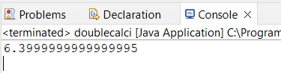

7.     Create a [JavaBean](https://aln.anudip.org/mod/resource/view.php?id=12692) class Person with properties firstName, lastName, age, and email. Implement the required no-argument constructor, getter and setter methods for each property. Write a main class to create an instance of Person, set its properties, and print them out.

-

**package** raju;

**public** **class** que7 {

**public** String firstname;

**public** String lastname;

**public** **int** age;

**public** String email;

**public** **void** setfirstname(String firstname) {

**this**.firstname=firstname;

}

**public** String getfirstname() {

**return** firstname;

}

**public** **void** lastname(String lastname) {

**this**.lastname=lastname;

}

**public** String getlastname() {

**return** lastname;

}

**public** **void** setemail(String email) {

**this**.email=email;

}

**public** String getemail() {

**return** email;

}

**public** **void** setage(**int** age)

{

**this**.age=age;

}

**public** **int** getage()

{

**return** age;

}

**public** **static** **void** main(String[] args) {

// **TODO** Auto-generated method stub

que7 obj=**new** que7();

obj.setfirstname("Aditya");

obj.lastname("Kamble");

obj.setemail("adityakamble948@gmail.com");

obj.setage(23);

System.***out***.println(obj.getfirstname());

System.***out***.println(obj.getlastname());

System.***out***.println(obj.getage());

System.***out***.println(obj.getemail());

}

}

Output-

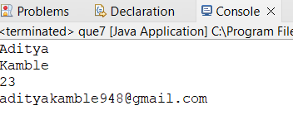

(8) Create a [JavaBean](https://aln.anudip.org/mod/resource/view.php?id=12692) class Car with properties make, model, year, and color. Implement the required no-argument constructor, getter and setter methods for each property. Write a main class to create an instance of Car, set its properties, and print the car details.

-

**package** raju;

**public** **class** car {

**public** String model;

**public** **int** year;

**public** String color;

**public** **void** setmodel(String model)

{

**this**.model=model;

}

**public** String getmodel()

{

**return** model;

}

**public** **void** setyear(**int** year)

{

**this**.year=year;

}

**public** **int** getyear()

{

**return** year;

}

**public** **void** setcolor(String color)

{

**this**.color=color;

}

**public** String getcolor()

{

**return** color;

}

**public** **static** **void** main(String[] args) {

// **TODO** Auto-generated method stub

car obj=**new** car();

obj.setmodel("xuv");

obj.setyear(2001);

obj.setcolor("black");

System.***out***.println("model="+obj.getmodel());

System.***out***.println("year="+obj.getyear());

System.***out***.println("color="+obj.getcolor());

}

}

Output-

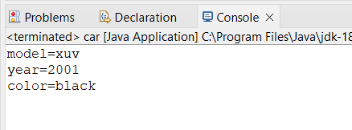

------------------------------**END**------------------------------------